|  |
| --- |
|  |
| Objects 5707 Date:1/10/2021 7:39:32 PM HV:30.0kV Puls th.:5.17kcps  El AN Series unn. C norm. C Atom. C Error (1 Sigma)  [wt.%] [wt.%] [at.%] [wt.%]  -----------------------------------------------------  C 6 K-series 63.33 63.33 71.86 8.50  O 8 K-series 23.64 23.64 20.14 3.90  Na 11 K-series 4.43 4.43 2.63 0.35  Cl 17 K-series 3.42 3.42 1.32 0.15  N 7 K-series 3.31 3.31 3.22 1.25  S 16 K-series 0.50 0.50 0.21 0.05  P 15 K-series 0.43 0.43 0.19 0.05  Si 14 K-series 0.24 0.24 0.12 0.04  Ca 20 K-series 0.23 0.23 0.08 0.04  Mg 12 K-series 0.19 0.19 0.11 0.04  Al 13 K-series 0.19 0.19 0.10 0.04  K 19 K-series 0.10 0.10 0.03 0.03  -----------------------------------------------------  Total: 100.00 100.00 100.00 |

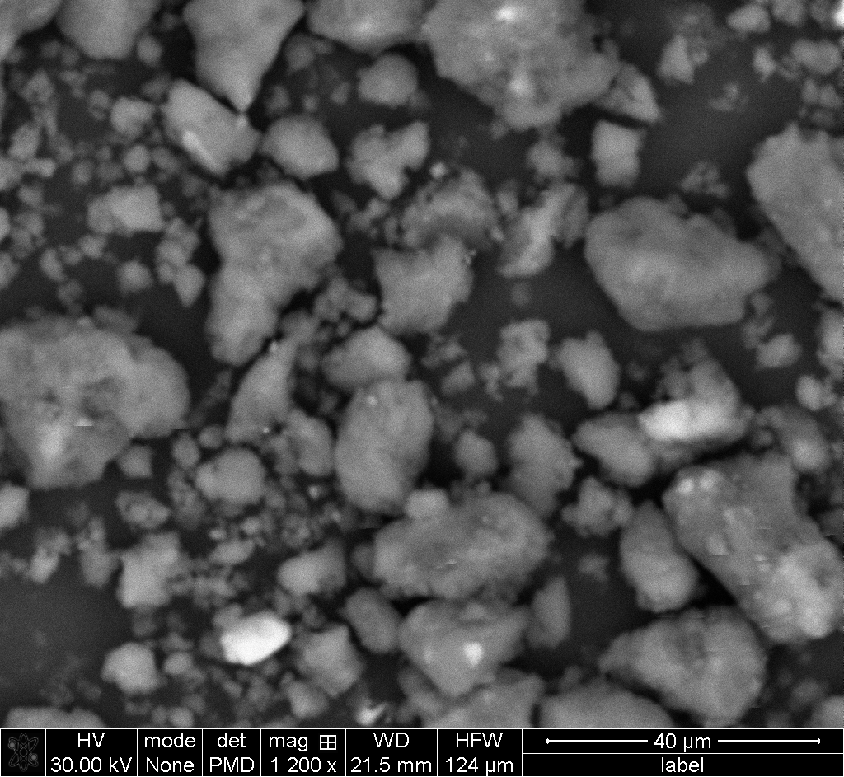

|  |
| --- |
|  |
| Map data 13661  Date:1/10/2021 7:40:51 PM  Image size:388 x 380  Mag:1029.49061662198x  HV:30.0kV | |

|  |
| --- |
|  |
| Map data 13661  Date:1/10/2021 7:40:51 PM  Image size:388 x 380  Mag:1029.49061662198x  HV:30.0kV | |

|  |
| --- |
|  |
| Map data 13661  Date:1/10/2021 7:40:51 PM  Image size:388 x 380  Mag:1029.49061662198x  HV:30.0kV | |

|  |
| --- |
|  |
| Map data 13661  Date:1/10/2021 7:40:51 PM  Image size:388 x 380  Mag:1029.49061662198x  HV:30.0kV | |

|  |
| --- |
|  |
| Map data 13661  Date:1/10/2021 7:40:51 PM  Image size:388 x 380  Mag:1029.49061662198x  HV:30.0kV | |

|  |
| --- |
|  |
| Map data 13661  Date:1/10/2021 7:40:51 PM  Image size:388 x 380  Mag:1029.49061662198x  HV:30.0kV | |

|  |
| --- |
|  |
| Map data 13661  Date:1/10/2021 7:40:51 PM  Image size:388 x 380  Mag:1029.49061662198x  HV:30.0kV | |

|  |
| --- |
|  |
| Map data 13661  Date:1/10/2021 7:40:51 PM  Image size:388 x 380  Mag:1029.49061662198x  HV:30.0kV | |

|  |
| --- |
|  |
| Map data 13661  Date:1/10/2021 7:40:51 PM  Image size:388 x 380  Mag:1029.49061662198x  HV:30.0kV | |

|  |
| --- |
|  |
| Map data 13661  Date:1/10/2021 7:40:51 PM  Image size:388 x 380  Mag:1029.49061662198x  HV:30.0kV | |

|  |
| --- |
|  |
| Map data 13661  Date:1/10/2021 7:40:51 PM  Image size:388 x 380  Mag:1029.49061662198x  HV:30.0kV | |

|  |
| --- |
|  |
| Map data 13661  Date:1/10/2021 7:40:51 PM  Image size:388 x 380  Mag:1029.49061662198x  HV:30.0kV | |